**PROJECT SYNOPSIS**

**ON**

**<<Blockchain Virtual Game World>>**

**Submitted by**

**<< Bhagyashri Rahul Bansode>>**

**Abstract :**

Today, digital asset ownership records are stored in a decentralized,

distributed database on the basis of blockchain technology. It is no longer

possible to modify any stored information on a Blockchain, which makes this

technology a legitimate disruptor for sectors such as payments, cybersecurity. Considering the increasing implementation of blockchain

technology in various fields, this paper aims at focusing its application as a

basic gaming experience to newbies, who wish to step into the world of

blockchain gaming. Firstly, this paper presents the conceptual design and

implementation of blockchain gaming in the framework of a 2D 3D game hosted.

This game highlights the incorporation of Fungible and Non-fungible tokens

(NFT), which represent the rewards collected by the player. The collected

reward bonus in the form of NFT is published on the player’s OpenSea

account, connected to MetaMask. The Game flow includes the development of

a user-friendly, theme-based interface supported by Solidity as a

technological support for building smart contracts using ERC20 and

ERC1155 token standards. IPFS (Inter planetary-file system) is used for

decentralized storage of metadata and token images, and Hardhat and

Alchemy for deployment and overall execution. This game demonstrates a

basic implementation of blockchain in gaming and unveils its broader scope

through its incorporation in even simple children’s games. This game carries

pedagogical significance which can be utilized by the professors to

demonstrate the practical usage of fundamental elements of blockchain to the gamers.

**The Intersection of**

**Blockchain and Gaming**

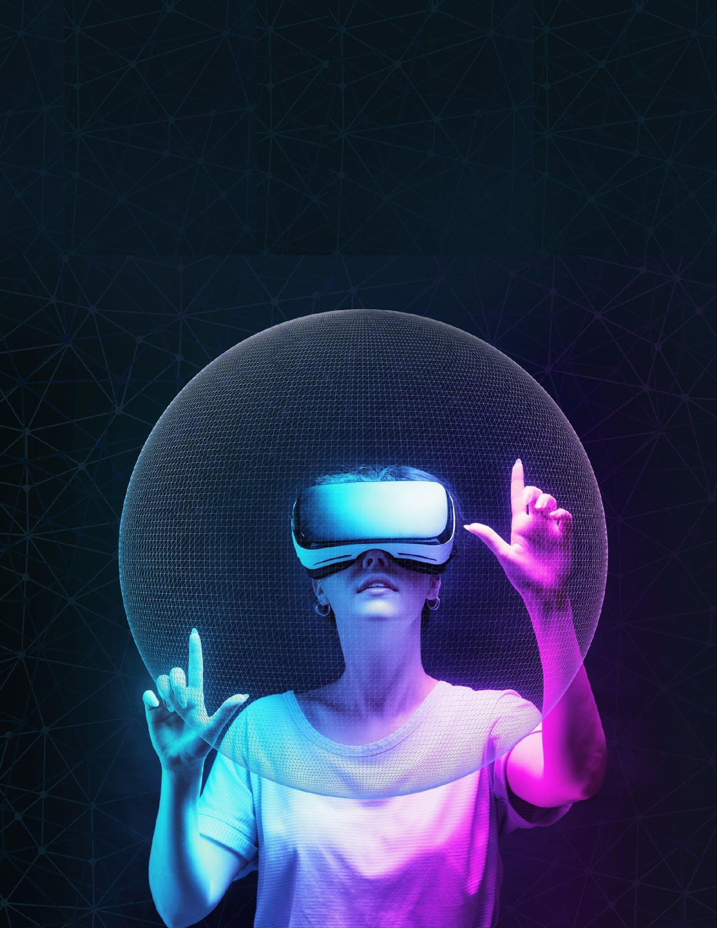

**Market Overview**

Investment into blockchain gaming is growing rapidly, with an estimated $2.5 billion raised in Q1 2023 and a projected 150% increase compared to last year in 20213. Current key players in the

blockchain gaming industry include game

publishers, platforms to serve as a marketplace, and Unlimited Realityplatforms to serve as shared

worlds in which players inhabit. While blockchain gaming currently occupies only a small share of the

$397+ billion industry, this increase in investment may signal an accelerated growth trajectory and

increased adoption of the technology. As more publishers evaluate incorporating blockchain into their games’ DNA, the technology will likely become integral to the industry.

Despite bullish figures, blockchain gaming may still be in its infancy. As of March 2024 blockchain gaming attracted 2.22 million unique active wallets (UAWs)a fraction of the total gaming market.

Given this early stage, it is still to be determined whether blockchain gaming will reach widespread adoption. While some publishers have announced plans to incorporate blockchain technology, others have been reluctant to embrace the concept of

digital ownership. If blockchain gaming hopes to capture widespread gaming audiences, it will likely need the backing of publishers to invest in high quality gaming experiences to drive player bases

(beyond the experimental, seed-funded games we see today), and the willingness to do so varies

across companies. For example, Forte recently raised $925 million for its blockchain game platform so gaming companies can create compliant and

interoperable blockchain games, while many major

publishers have yet to enter the space. *increase compared to last year.*

There seems to be a clear industry bifurcation between traditional publishers and blockchain gaming developers. The former appears to be cautious about digital assets and blockchain, particularly after initial efforts were met with disapproval from players. The latter is bullish and opportunistic, with mixed results thus far. Some blockchain-native companies have launched fun, innovative games, while others have focused on novel monetization opportunities at the expense of quality in gameplay. With console

manufacturers and major publishers being critical for mass adoption, it remains to be seen whether and how they will embrace blockchain gaming into their offerings.

**Smart contract Extraction Example**



**Technology support:**

1. Solidity:

The Solidity programming language is used to create

smart contracts running on the Ethereum Virtual

Machine. Smart contracts are programs carried out

within a peer-to-peer network, where no one has

specific responsibility for their execution and so they let

anyone make token of value, ownership, voting or other

types of logic.

In this game, we have used solidity to develop smart

contracts for defining rules for reward collection which

will be implemented every time a player loses and

wishes to collect his rewards.

We have drafted two smart contracts using two token

standards: ERC1155 AND ERC20, for minting NFT’s

and token collection respectively.

* 1. ERC 20

An ERC20 token contract tracks fungible, i.e., any one

token is identical to all others, and there are no special

rights or behavior associated with them. This makes

ERC20 tokens useful for things like a medium of

exchange currency, staking, voting rights, and more. A

number of ERC20 related contracts are offered by

OpenZeppelin Contracts Using these contracts, we have created our own ERC20token contract, which will be used to track Game Score(POCOS), an internal currency MotoUnicorns. game.

1.2. ERC 1155

The ERC 1155 is the single token for creating alltypes of assets, from currency and real estate to Digital Art and Games. ERC 1155 makes it possible to include a large number of assets in one SmartContract, which enables them to be transferred with

limited network congestion and reduced transaction

costs. The support for non-fungible and fungible

tokens will be another significant feature of the ERC09o0i

1155 token standard.

(https://docs.ethers.org/v5/api/signer/)

Using Contracts, we have created our own ERC1155

token contract, which will be used to Collect the nonfungible

tokens in form of rewards in MetaVerse

game.

1. IPFS

The Inter Planetary File System, or IPFS for short, is a

peer-to-peer hypermedia protocol which aims to create a

worldwide, decentralized file system that stores and

shares files. By allowing files to be stored in a range of

locations, which is resistant to censorship and ensures

that they can always be accessed while some nodes are

down, it hopes to improve the performance and

resilience of existing web protocols.

The IPFS loads the content from thousands of peers

instead of one centralized server. Every piece of data

stored gets a unique content identifier (CID), which is

cryptographically hashed. This prevents duplication of

similar files in storage

(https://docs.ipfs.tech/concepts/how-ipfs-works/)

We have used IPFS to store the NFT token images and

token metadata, which can be directly accessed by the

game to mint the NFT’S on the OpenSea account.

3. Hardhat:

Without being confronted with real environments,

Hardhat helps you easily deploy your contracts, run

tests and debug Solidity code. The Hardhat Network is

an Ethereum local network that's intended for

development and debugging Solidity. When transactions

are unable to be performed, you will receive Solidity

stack traces, console.log and explicit error messages,

which simplifies the overall execution of task.

We have used hardhat for compiling and deploying our

contract on polygon testnet network.

4. Alchemy:

To help you create and scale your DApp with ease, this

is the most comprehensive set of web3 development

tools. Alchemy is a platform for developers that enables

companies to build and maintain reliable, decentralized

applications without having to manage the scalable

infrastructure of the blockchain. Moreover, currently it

is more reliable, and scalable in comparison to the rest of the solutions on the market while being extremely

simple to integrate! Alchemy's software tools provide an

out of the box kit that is especially helpful for scaling

cryptocurrencies, particularly for Ethereum blockchain

applications. It's also allowing crypto firms to speed up

complex and expensive tasks like debugging and

writing for nodes. (https://www.alchemy.com/)

We have used Alchemy as a service provider for testing

the working of our DApp(game) on Polygon test net

network.

**Sample MetaUniverse**



**Revenue Generation**

From a revenue generation standpoint, blockchain gaming has the potential to create new avenues for monetization. However, where the use case of the technology remains unclear is around an often

overlooked, but crucial factor: is it simply fun? For blockchain gaming to succeed, digital assets likely can’t just be an attractive investment opportunity; they should solve for the element of entertainment value and create use cases that lead to compelling new forms of gameplay for players.

As it stands, many of the emerging titles we see today have designed early use cases, but it could be arguable none have managed to present high-quality gameplay experiences. A strong core gameplay loop should be able to stand on its own to sustain a player’s attention, and very few games in the blockchain gaming space have presented particularly notable or compelling forms of gameplay. There are likely two reasons for this:

**1. Games which follow a play-to-earn model**

**tend to incentivize player engagement through extrinsic rewards, rather than**

**inherent fun or entertainment value.** Games which follow a play-to-earn model tend to incentivize player engagement through extrinsic rewards, rather than inherent fun or entertainment value. Whereas traditional retail titles should earn sales through offering and delivering on great experiences, many blockchain games attract audiences through an inflated promise of earning potential, which on its own likely can not sustain a platform (especially when a disproportionate amount of a player base is seeking to profit).

**2. The average blockchain game on the current**

**market lacks depth, strong gameplay design, and quality that players are accustomed to in the traditional gaming space.** More akin to a tech demo than a real game, many blockchain games have creative ideas, and present one dimensional experiences with limited reason for players to engage in sustained, lengthy gameplay.

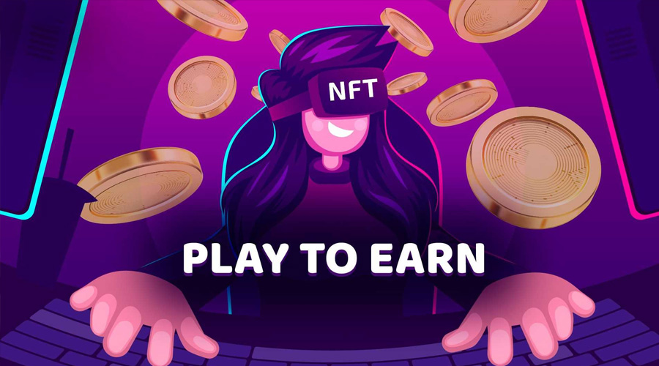

Digital Use Cases In Gaming

**1. In-Game Merchandise**

These can be a) functional items, bonuses, tools, or stat-boosts that impact the gameplay or abilities of the player; or b) items which purely affect the appearance, aesthetic, or mannerisms of a player’s character or environment. Like a mount in an adventure game or uniform camouflage in action titles, these items promote personalization of gameplay. This becomes increasingly important as games evolve into social hubs and metaverses, where players can not only compete within game worlds, but also socialize and participate in events, such as Fortnite’s in-game concert.

**2. Collectibles**

Similar to virtual baseball cards, these items have no impact on gameplay or appearance, but are items that can be viewed, managed, and stored in-game, or in other cases within a broader ecosystem dabbled with collectible items in the past, but digital assets expand upon collectability to bear the ability to buy, sell, and swap from other players, creating a metagame which

forms entire communities.

. **3. Access**

**Tokens**

Assets which if owned, provide access to in game or real-world events or items. Perhaps a developer wants to beta test a game, but only wants a limited number of dedicated players to do so? Tokens can be used to grant specific groups access to content based on ownership. Similarly, if that same developer were to host a launch-event in New York to celebrate the release of their title, tickets could be distributed in the form of digital assets, creating an experience that translates across virtual and physical worlds that also allows publishers to recognize and reward their most loyal players.

**4. Private Chains**

A compelling value proposition for publishers is the ability to create exclusive in-game economies, which could entail royalty payments or digital asset transfers to players that can only be earned and reused within the publisher’s environment. Private chains enable this exclusivity, creating stickiness for capturing and retaining players within a platform or game. The use of private chains to enable platform economies provides the benefit of exclusivity as well as reduced transaction friction.

**The use cases for Digital Assets in games will likely continue to evolve and permutate based on emerging trends, consumer behaviours, and technologies that** **drive new gameplay experiences. As widespread adoption occurs, so too can innovation within how developers choose to leverage digital assets.**



Conclusion

The game implemented is very user-friendly,

easy to understand and play, Having many options to create

their own characters and own imaginary worlds.

Primarily, it helps to get insights and

experience with blockchain gaming at an elementary

level. As a future scope, we can include various levels

of the game with some complicated tasks and integrate

the usage of collected tokens as a medium of some

advantage in upcoming levels of game. There is a high

scope of advanced UI/UX design to the game with

improved game process. Earning method developers make money by charging for primary market transactions. they will have the option to organize auctions to sell their creativity.

**Thank You**